**“A Project Report On "Gym Management System"**

**Prepared by:**

20DCE016 – Khushbu Chauhan

20DCE019 – Yatharth Chauhan

20DCE024 – Deep Dhaduk

**Under the guidance of**

Prof. Janardan Bharvad, Prof. Sachi Joshi and Prof. Shraddha Vyas

A Report Submitted to Charotar University of Science and Technology

for Partial Fulfilment of the Requirements for the 4th Semester

Software Group Project-II (CE255)

**SUBMITTED AT**



**DEVANG PATEL INSTITUTE OF ADVANCE TECHNOLOGY & RESEARCH**

**Department of Computer Engineering**

**CE - DEPSTAR**

**AT: CHANGA, DIST: ANAND – 388421**

**APRIL 2022**



**CERTIFICATE**

This is to certify that the report entitled “Gym Management Sytem” is a bonofied work carried out by **Yatharth Chauhan(20DCE019), Khushbu Chauhan(20DCE016)**, **Deep Dhaduk(20DCE024)** under the guidance and supervision of **Assistant Prof. Janardan Bharvad, Prof. Sachi Joshi and Prof. Shraddha Vyas** for the subject **CE255-Software Group Project-II** (CE) of 4th Semester of Bachelor of Technology in **DEPSTAR** at Faculty of Technology & Engineering – CHARUSAT, Gujarat.

To the best of my knowledge and belief, this work embodies the work of candidate himself, has duly been completed, and fulfills the requirement of the ordinance relating to the B.Tech. Degree of the University and is up to the standard in respect of content, presentation and language for being referred to the examiner.

|  |  |
| --- | --- |
| Prof. Janardan Bharvad, Prof. Sachi Joshi and Prof. Shraddha Vyas  Computer Engineering (CE)  DEPSTAR, Changa, Gujarat. |  |
| Dr. Amit Ganatra  Principal, DEPSTAR  Dean, FTE  CHARUSAT, Changa, Gujarat. | |

**Devang Patel Institute of Advance Technology And Research At: Changa, Ta. Petlad, Dist. Anand, PIN: 388 421. Gujarat**

**ACKNOWLEDGEMENT**

We have great pleasure in acknowledgement the help from all those who favoured me in having shape to the present project. The development of this project has given me wide opportunity to think, implement and interact with various aspects of management skills as well as the new emerging technologies. We take the responsibility to express our sincere and deep sense of gratitude to our head of department **Dr. Amit Ganatra.** Our facility members and all our friends. We pay our thanks to **Prof. Janardan Bharvad, Prof. Sachi Joshi and Prof. Shraddha Vyas** for providing a great support to us. They guided our project team efficient and good working.

We like to pay our wish and love to our all supporting friends who made their best efforts to help us. Words defeat us in expressing thanks to our family members for providing moral support and encouragement during the tenure of the project.

We hope and wish to be blessed with the blessing and encouragement from all of the above in our future to accomplish all our endeavours.

Thanks,

20DCE016 – Khushbu Chauhan

20DCE019 – Yatharth Chauhan

20DCE024 – Deep Dhaduk

|  |  |
| --- | --- |
| Project | **Software Group Project - II** |
| Project Name | **GYM MANAGEMENT SYSTEM** |
| Semester | **4th Semester** |
| Submitted to | **CHAROTAR University** |
| Under the supervision of | **Prof. Janardan Bharvad, Prof. Sachi Joshi and Prof. Shraddha Vyas** |
| Team Members | **20DCE016 –Khushbu Chauhan**  **20DCE019 – Yatharth Chauhan**  **20DCE024 – Deep Dhaduk** |

**DOCUMENTATION INFORMATION**

**Acknowledgement………………………………………..i**

**Abstract………………………………………………….ii**

**Documentation Information…………………………….iii**

**TABLE OF CONTENTS**

**CHAPTER – 1: INTRODUCTION**

1.1 Abstract.................................................................................1

1.2 Objective………………………………….…………………….1

* 1. Scope......................................................................................1
  2. Tools and Technology............................................................1
  3. Features Of Project…………………………………………1

**CHAPTER – 2: SYSTEM ANALYSIS**

2.1 Problem Definition of the Existing System…………..………………2

2.2 WhatI is the Problem………………………………..……………..……2

2.3 Limitations…………………………………………………….............2

**CHAPTER – 3: SYSTEM REQUIREMENTS STUDY**

* 1. User Characteristics...............................................................3
  2. Hardware Specifications..………….……………………….3
  3. Software Specification….…………………………………..3

3.4 Assumptions And Dependencies…………………………….3

**CHAPTER – 4: SOFTWARE SYSTEM ATTRIBUTES**

4.1 Usability………………………………………………….……………4

4.2 Efficiency…………………………………………………….………..4

4.3 Maintainability…………………………………………………..……..4

4.5 Reliability……………………….……………………………………..4

* 1. Performance…………………..………………………………………..4

**CHAPTER – 5: PROJECT MANAGEMENT**

5.1 Gantt Chart……………………………..…………………………….5

**CHAPTER – 6: SYSTEM DIAGRAMS**

6.1 Data Flow Diagram…………………………………………………..…6

6.2 Preview…………………………………………………………………..6

**CHAPTER – 7: SYSTEM DESIGN**

7.1 Header Bar………………………………………………7

7.2 Source Code………………………………………………7

7.3 References………………………………………………7

**CHAPTER – 8: CONCLUSION**

# **CHAPTER 1: INTRODUCTION**

# The “Gym Management System" has been developed to override the problems prevailing in the practicing manual system. This software is supported to eliminate and in some cases reduce the hardships faced by this existing system. Moreover this system is designed for the particular need of the company to carry out operations in a smooth and effective manner. Thus this application provides the required information in less time and also helps in quicker decision making.

* Our Gym Management Software is a gym membership management system. You can keep records of your members, Plans, Payments invoice, Health Status.

# Focuses mainly on dealing with the customer regarding their payments, routines, records.

* An admin can view overall reports of their members under monthly reports and yearly reports.
* Also, he/she can view total income per month which displays the member’s name with id, gender, contact, payment date, expiry date, plan name, amount, and certain validity respectively.
* Lastly, the system allows the admin to update the profile which includes username, full name, and the user can change their password information too.

# Also, the system displays all the available data such as customer’s details with their respective payment amount, routines, and health status.

# The project contains an Admin Panel. n an overview of this web app, the admin has access to register customers as well as maintain their payment records.

# Talking more about the project, the admin can create new plans for the customer’s payment.

# In terms of health status, he/she has to update each and every customer’s profile with current weight, height, calories, fats, etc.

# Besides, the admin can also manage exercise routines up to a week’s routine.

* The application is reduced as much as possible to avoid errors while entering the data. It also provides error message while entering invalid data. No formal knowledge is needed for the user to use this system. Thus by this all it proves it is user-friendly. Gym Management System, as described above, can lead to error free, secure, reliable and fast management system. It can assist the user to

concentrate on their other activities rather to concentrate on the record keeping. Thus it will help organization in better utilization of resource

**1.1 Abstract**

The purpose of Gym Management System is to automate the existing manual system by the help of computerized equipment’s and full-fledged computer software, fulfilling their requirements, so that their valuable data/information can be stored for a longer period with easy accessing and manipulation of the same. The required software and hardware are easily available and easy to work with.

Gym Management System, as described above, can lead to error free, secure, reliable and fast management system. It can assist the user to concentrate on their other activities rather to concentrate on the record keeping. Thus it will help organization in better utilization of resources. The organization can maintain computerized records without redundant entries. That means that one need not be distracted by information that is not relevant, while being able to reach the information.

The aim is to automate its existing manual system by the help of computerized equipment’s and full-fledged computer software, fulfilling their requirements, so that their valuable data/information can be stored for a longer period with easy accessing and manipulation of the same. Basically the project describes how to manage for good performance and better services for the clients.

* 1. **OBJECTIVE**
* The main objective of the Project on Gym Management System is to manage the details of gym members , Plans, Payments invoice. The project is totally built at administrative end and thus only the administrator is guaranteed the access. The purpose of the project is to build an application program to reduce the manual work for managing the Gym
* Design and develop a user friendly system.
* Easy to use and efficient computerized system.
* To develop an accurate and flexible system, it will eliminate data redundancy.
* Computerization can be helpful as means of saving time & money.
* To provide better graphical user interface.
* Less chances of information leakage.
* Provides security to data by using login & password.
  1. **SCOPE**

It may help collecting perfect management in details. In a very short time, the collection will be obvious, simple and sensible. It will help a person to know the management of passed year perfectly and vividly. It also helps in current all works relative to Gym Management System. It will be also reduced the cost of collecting the management & collection procedure will go on smoothly. Our project aims at Business process automation, i.e. we have tried to computerize various processes of Gym Management System.

The system generates types of information that can be used for various purposes.

It satisfy the user requirement

* Be easy to understand by the user and operator
* Be easy to operate
* Have a good user interface
* Be expandable
* Delivered on schedule within the budget.
  1. **TOOLS AND TECHNOLOGIE**
* Fronted: HTML, CSS, JS, Bootstrap
* Backend: phpMyAdmin, MySQL
  1. **Features Of Project**
* Admin Panel
* Customer Registration
* Make Payments
* Maintain Health Status
* Create and manage plans
* Overall reports
* Manage routines

**CHAPTER 2: SYSTEM ANALYSIS**

**2.1 Problem Definition of Existing System**

* Entering the details about the blood groups, members, name, date of birth etc. And tracking the database is complicated when the details are maintained. This makes the maintenance of schedule erroneous.
  1. **WHAT IS THE PROBLEM**
* The gym is working manually. The current system is time consuming because registration process to add members. To manually handle the system was very difficult task. But now-a-days computerization made easy to work.
* The following are the reasons why the current system should be computerized:
* To increase efficiency with reduced cost.
* To reduce the burden of paper work.
* To save time management for recording details of each and every member and employee.
* To generate required reports easily.
  1. **LIMITATIONS**
* **Time consumption**: **As the records are to be manually maintained it consumes a lot of time.**
* **Paper work**: Lot of paper work is involved as the records are maintained in the files & registers.
* **Storage requirements**: As files and registers are used the storage space requirement is increased.
* **Less reliable**: Use of papers for storing valuable data information is not at all reliable.
* **Accuracy**: As the system is in manual there are lot many chances of human errors. These can cause errors in calculating mechanism or maintaining customer details.
* **Difficulty in keeping new records**: It is difficult for keeping all the new entries of members, their account and transaction details.

**CHAPTER – 3: SYSTEM REQUIREMENTS STUDY**

* 1. **USER CHARACTERISTICS**
* The system requires user to be familiar with the basic operations of computer

* 1. **HARDWARE SPECIFICATION**
* **Processor: 1.2 GHz or more**
* **Ram: 1 GB or more**
* **HardDisk: 2 GB or more**
  1. **SOFTWARE SPECIFICATIONS**
* Operating System: Windows XP, 7, 8, 10,11
* Web Browser: Explorer, Firefox, Google Chrome
* Language Used: HTML, CSS, **JavaScript,** PHP, **PhpMyAdmin, MYSQL, bootstrap.**
  1. **ASSUMPTIONS AND DEPENDENCIES.**
* Project will work for a long time and user will adopt it.
* Project will work with very less maintenance requirement.
* The database update made by the system will always leave the system in consistent state.
* There may be some small problems, which will not affect the system performance, and these will be removed easily.
* Login Process
* This system interface is used to give access to the user for the system, and mean while maintaining the security of the system.

**CHAPTER – 4: SOFTWARE SYSTEM ATTRIBUTES**

**4.1 USABILITY**

* The system is fully usable and does not require any pre-specified constraint to work properl
  1. **EFFICIENCY**
* Hardware should me min. Pentium with 196 MB RAM(Fully efficient in the environments having less memory available and a reasonable speed of execution)  
  1. **MAINTAINABILITY**
* In case of any change in policies and rule of the institution using the system, required changes will be made to the module written by developer.
  1. **SECURITY**
* Only the super user can enter the system to use it
  1. **RELIABILITY**
* System gives accurate result without any errors
  1. **PERFORMANCE**
* System itself is quite fast.

**CHAPTER – 5: PROJECT MANAGEMENT**

* 1. **Gantt Chart**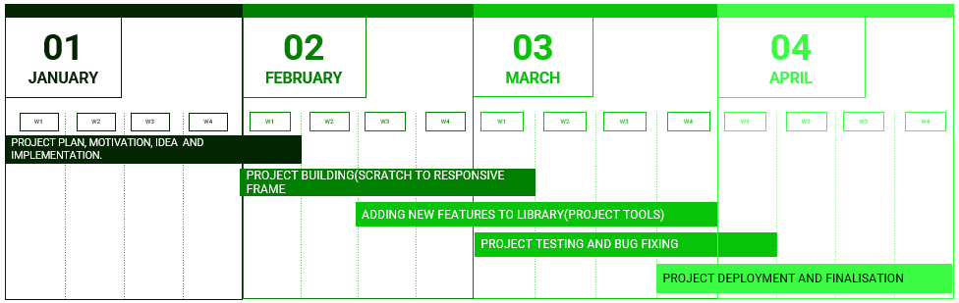

**CHAPTER – 6: SYSTEM DIAGRAMS**

* **DATA FLOW DIAGRAM**

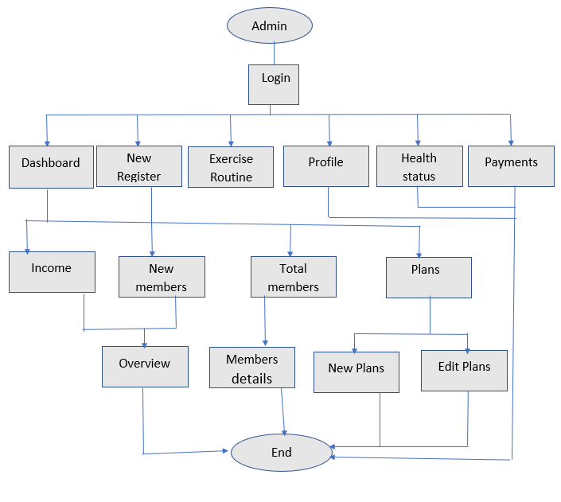

* **Login Page**

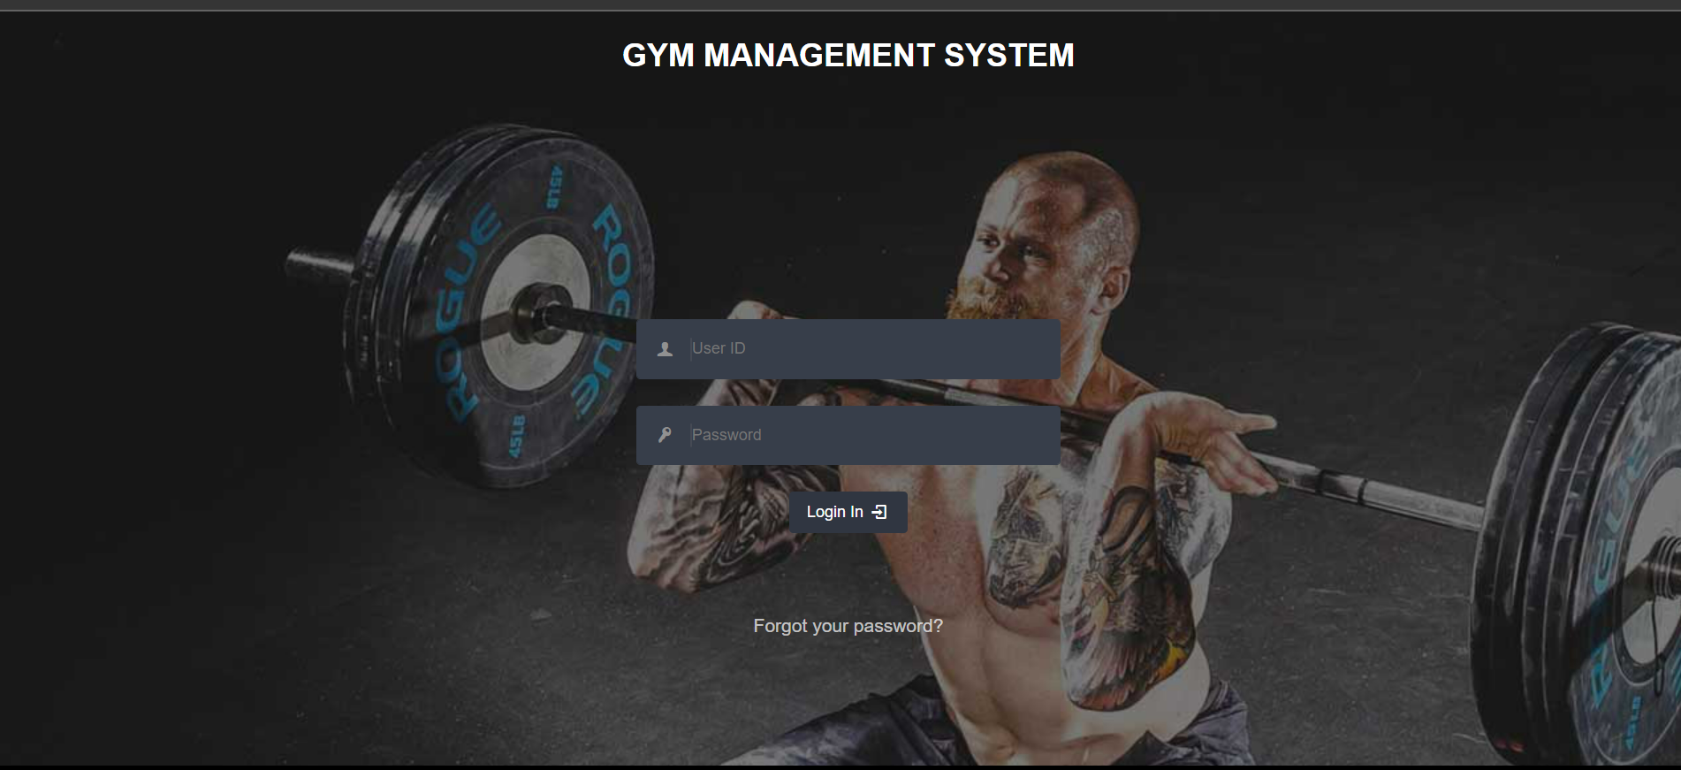

Admin Login Page

* **Dashboard**

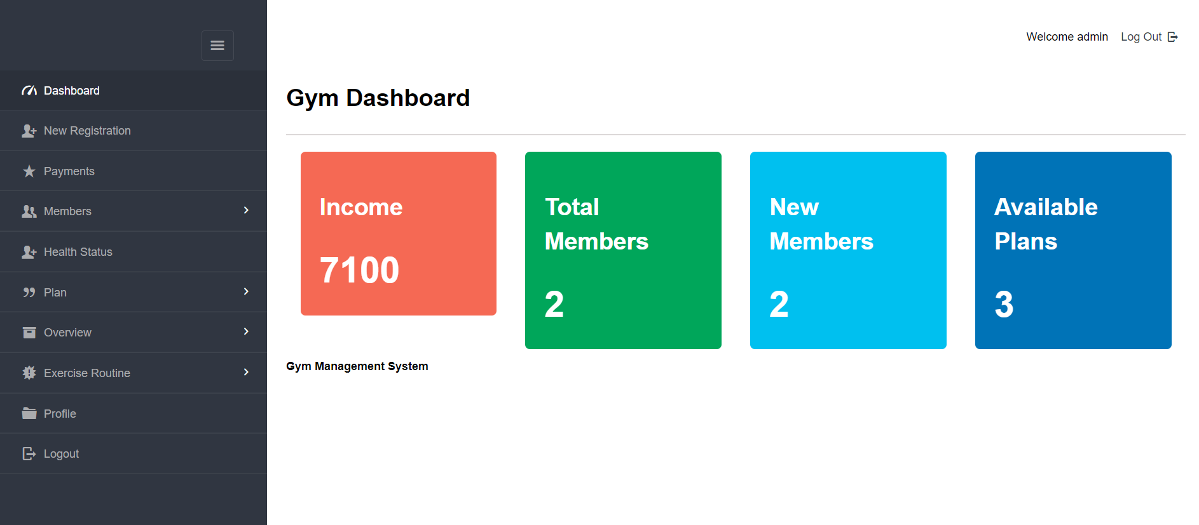

Dashboard

* **Registration Page**

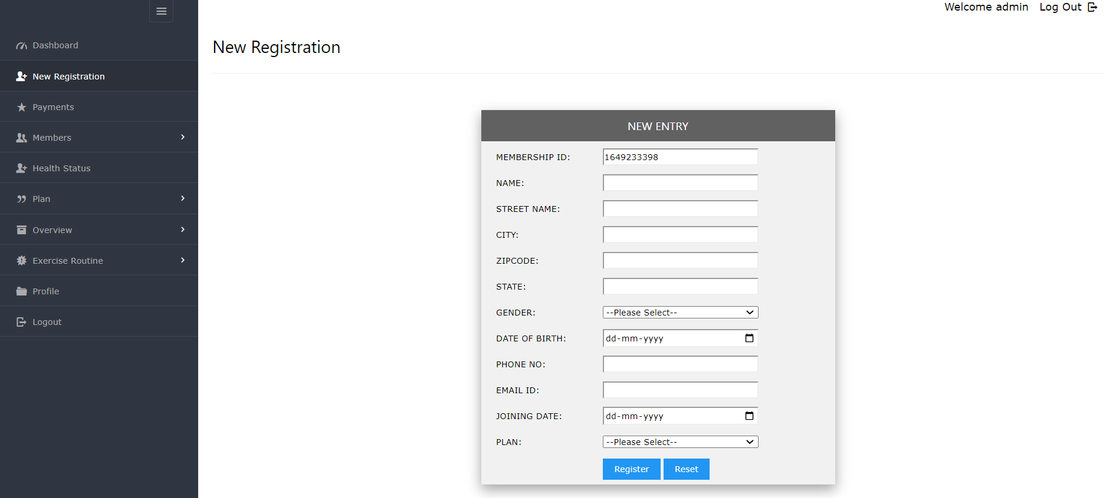

Registration Page

**CHAPTER – 7: SYSTEM DESIGN**

**7.1 HEADER BAR**

* Dashboard
* New Register
* Exercise Routine
* Profile
* Health Status
* Payments

**7.2 REFERENCES**

* [**https://www.perfectgym.com/en**](https://www.perfectgym.com/en)
* [**https://www.gymmaster.com/**](https://www.gymmaster.com/)
* [**https://www.gymmaster.com/**](https://www.gymmaster.com/)

**7.3 SOURCE CODE-GITHUB LINK**

<https://github.com/YatharthChauhan2362/GYM-Management-System>

**CHAPTER – 8: CONCLUSION**

* This report presents The Gym Management System related issues.
* The objectives of project is implemented by implementing the different plans such as time estimated through Gantt chart, work background, flowchart etc...
* Online Gym Management System make work easy, and ensures fast retrieval of data when needed.